Assignment 2

Pattern Recognition & Machine Learning CS

Sheikh Faiz Meraj CS22M081

1. **You are given a data-set with 400 data points in {0, 1} 50 generated from a mixture of some distribution in the file A2Q1.csv. (Hint: Each datapoint is a flattened version of a {0, 1} 10×5 matrix.)**
   1. **Determine which probabilisitic mixture could have generated this data (It is not a Gaussian mixture). Derive the EM algorithm for your choice of mixture and show your calculations. Write a piece of code to implement the algorithm you derived by setting the number of mixtures K = 4. Plot the log-likelihood (averaged over 100 random initializations) as a function of iterations.**

EM derivation is as follows:

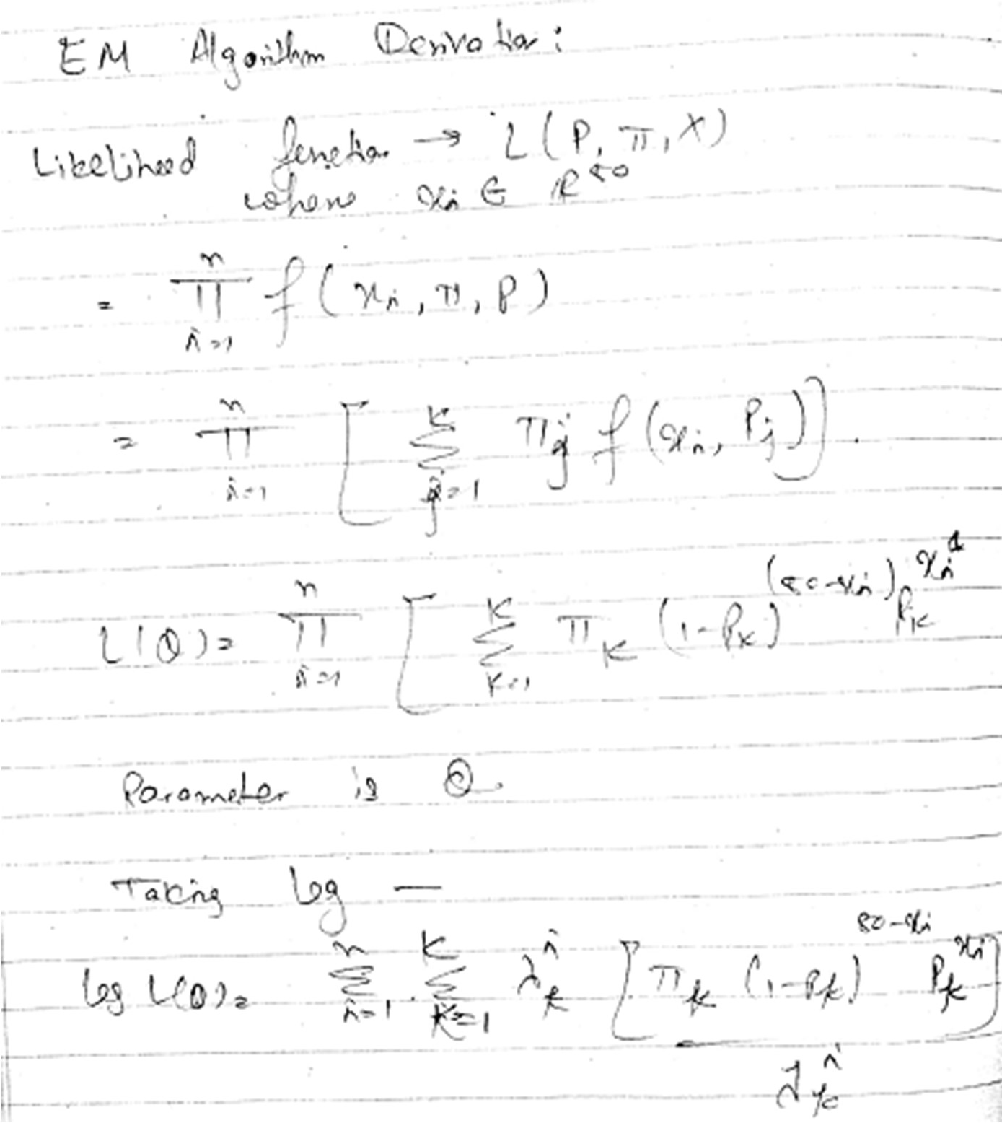

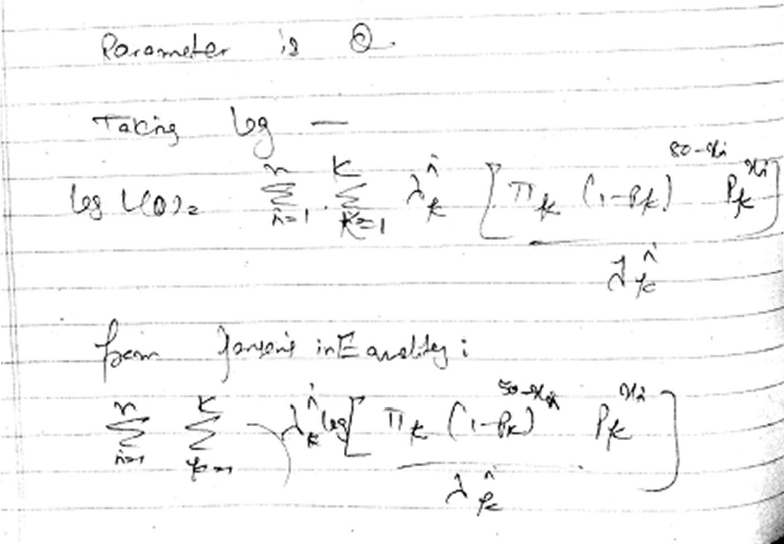

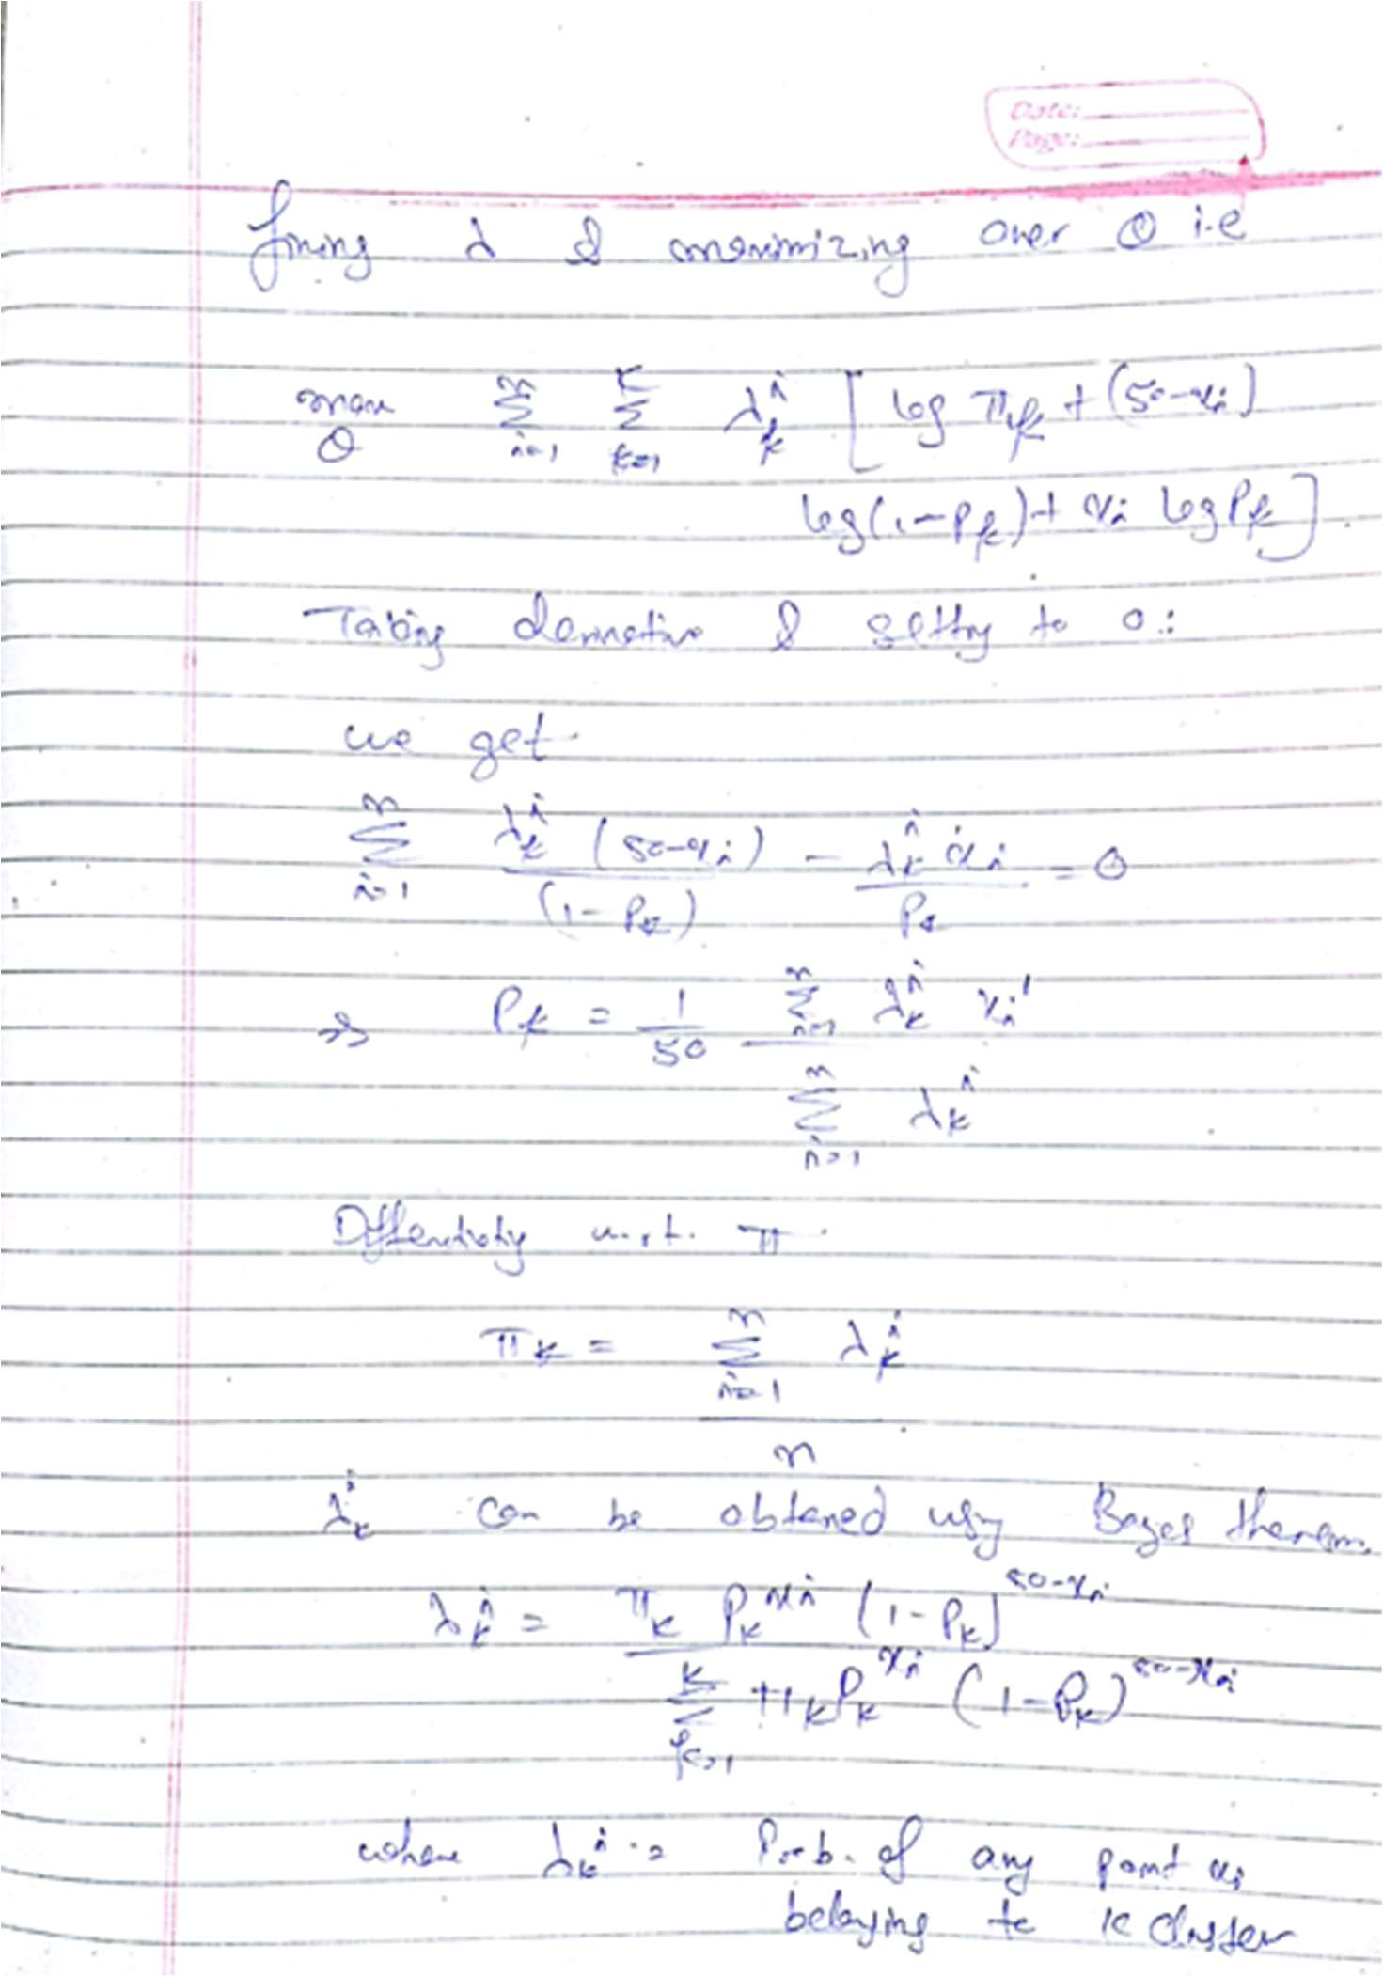

Code snippet for the EM algorithm is as follows:

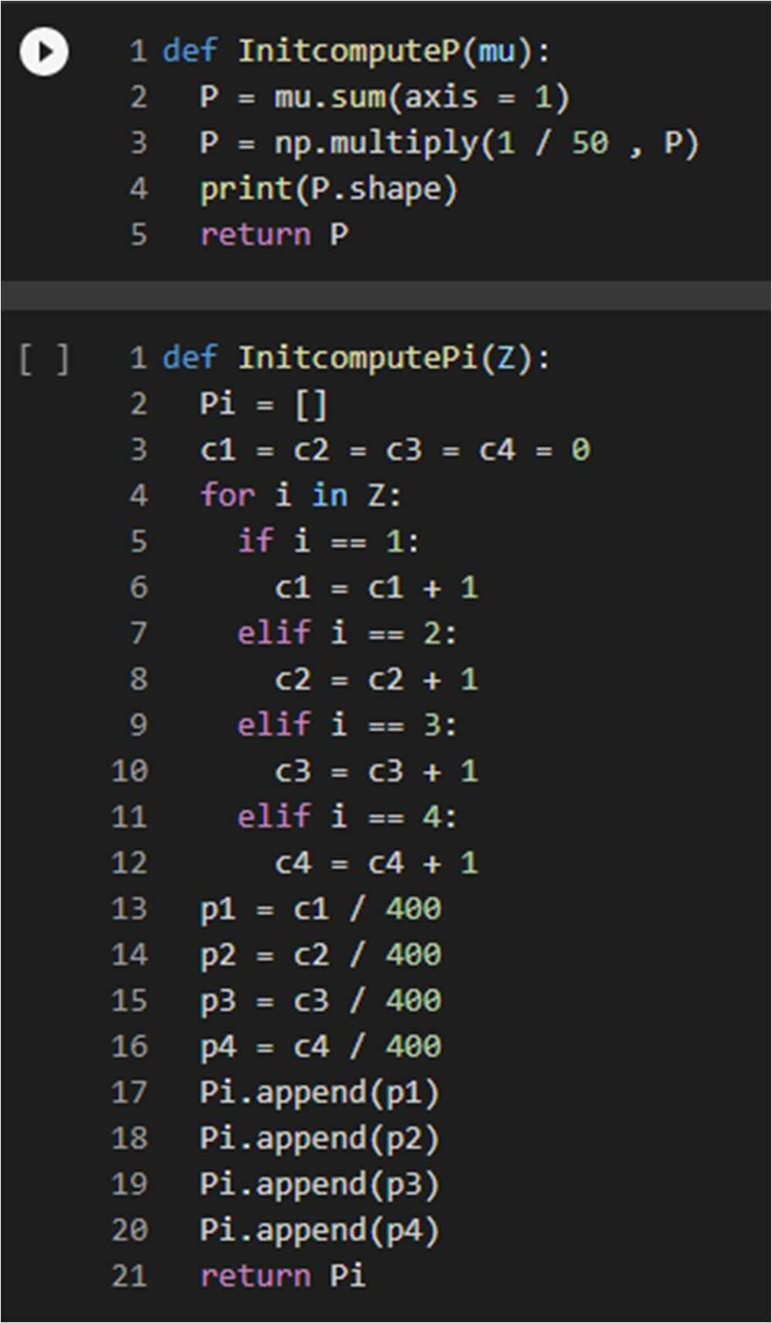

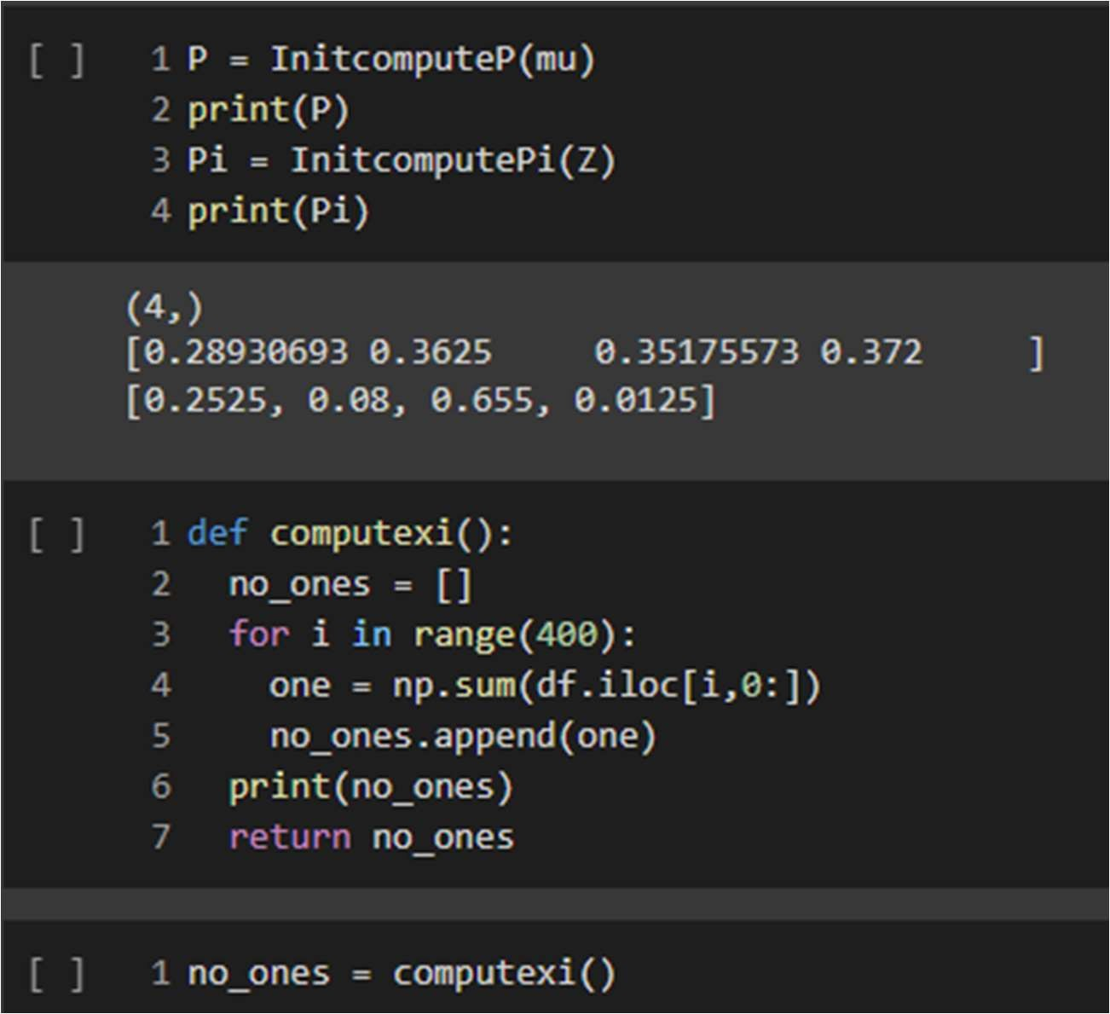

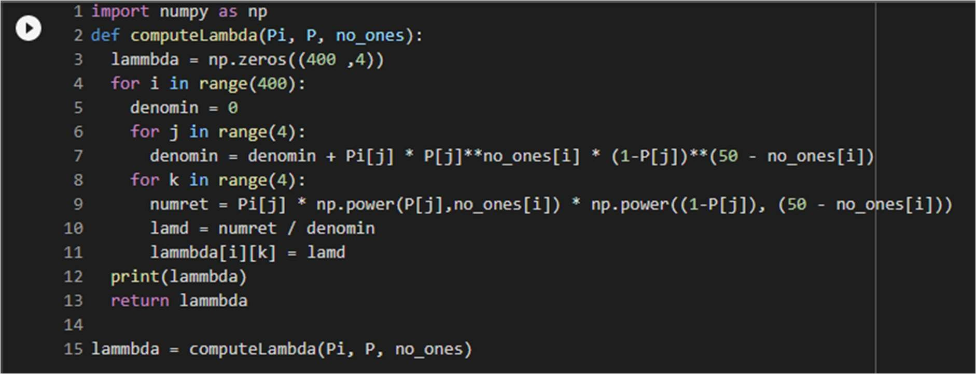

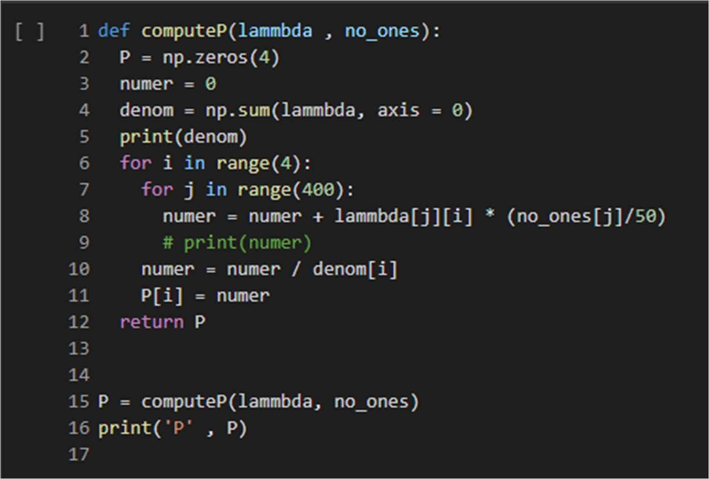

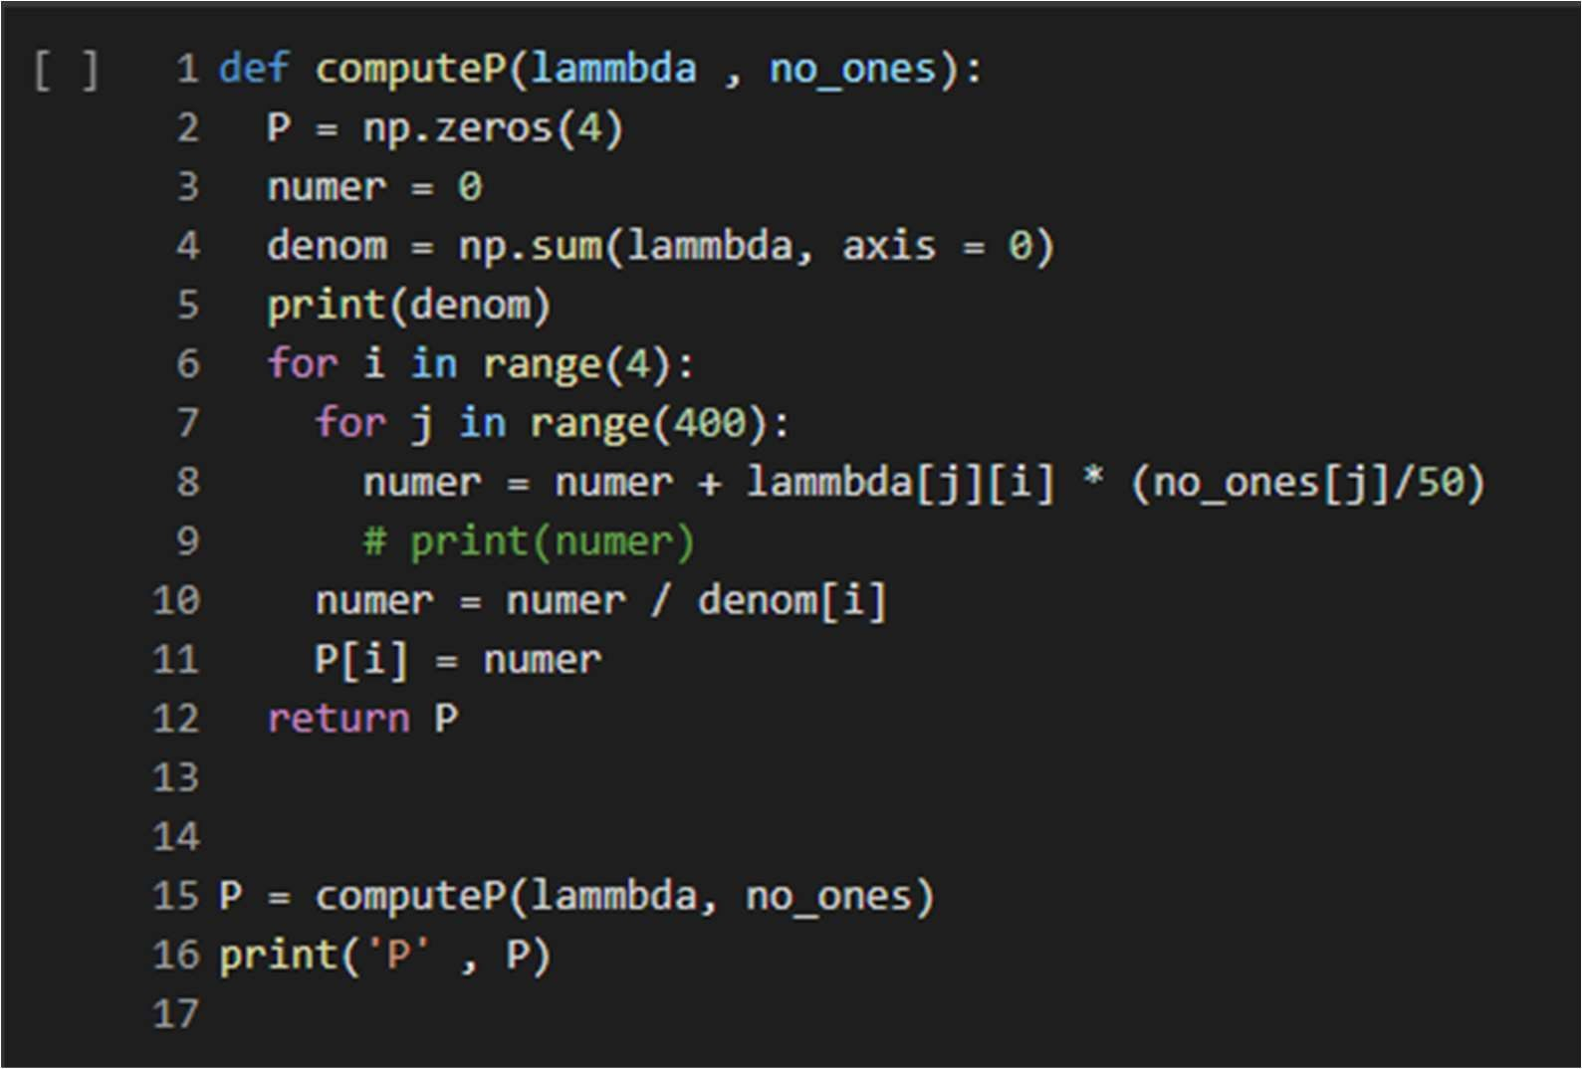

**iii. Run the K-means algorithm with K = 4 on the same data. Plot the objective of K − means as a function of iterations.**

Following is the code snippet for the k-means algorithm for the given dataset.

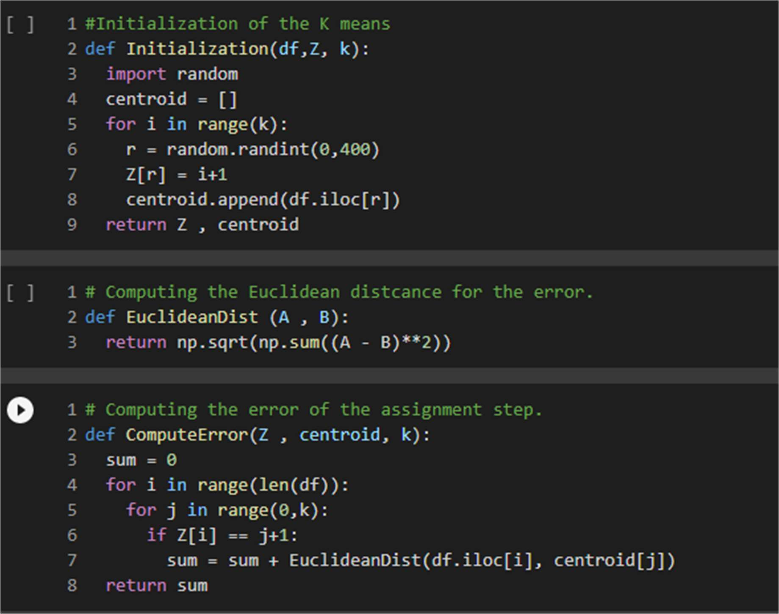

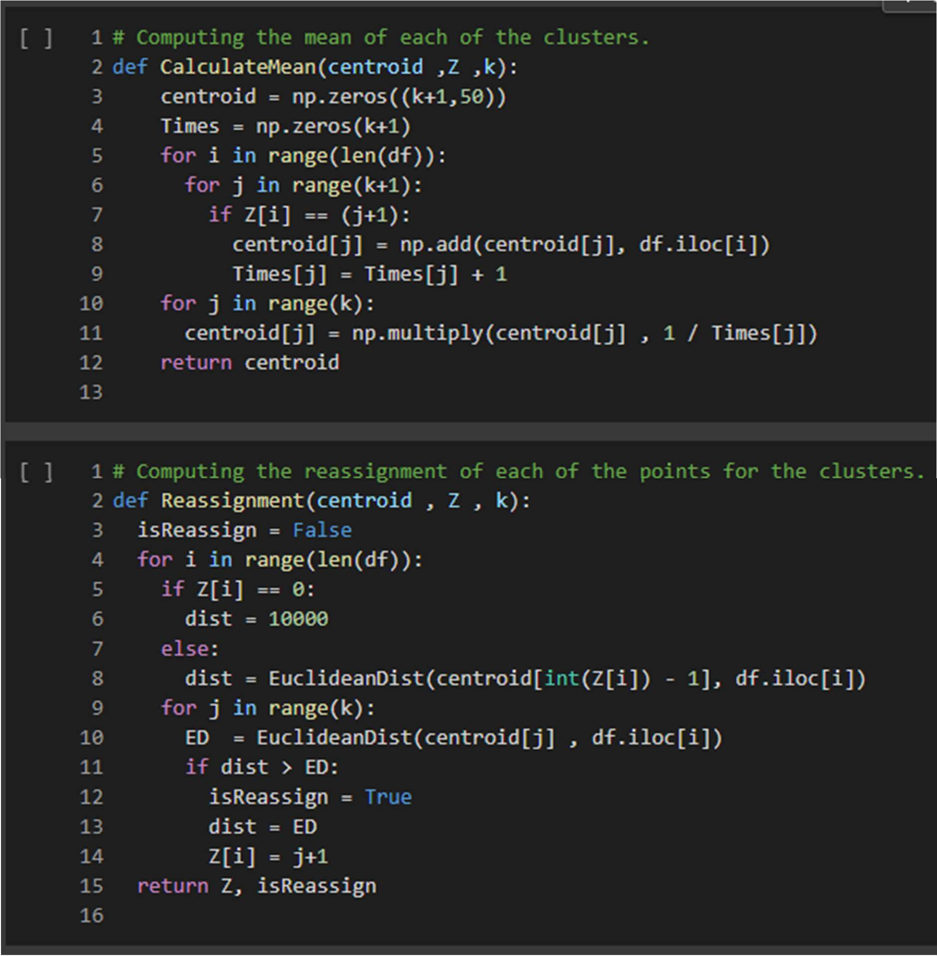

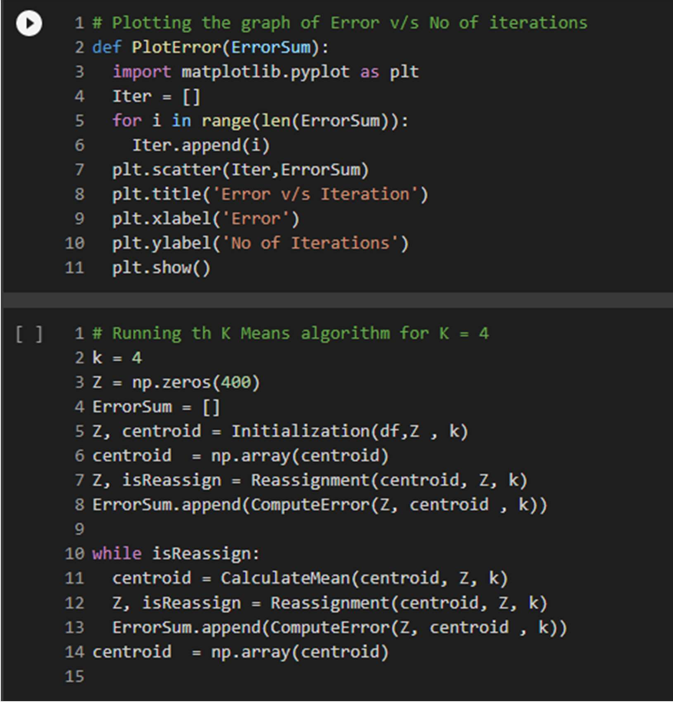

The error plot v/s the number of iterations after running the k means comes out to be as follows:

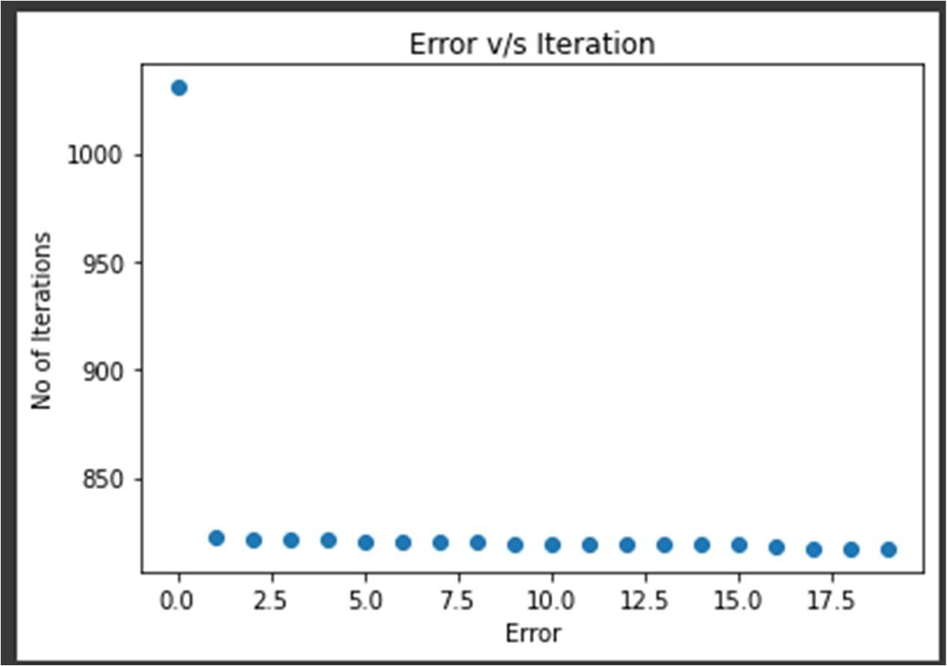

And the Error values comes out to be as:

|  |  |  |
| --- | --- | --- |
| [1030.529696607429, | 822.3213665089061, | 821.5034651299643, |
| 821.0839635549501, | 820.9569314319076, | 820.708525425563, |
| 820.342762948325, | 820.0051716011207, | 819.8457937253746, |
| 819.6902233246408, | 819.5071436513126, | 819.3122145114503, |
| 819.2265290532854, | 819.1154423278472, | 819.0532195432148, |
| 818.8814370395679, | 818.5388284731514, | 817.6130983204259, |

817.3496250537295, 817.1938824468676]

1. **You are given a data-set in the file A2Q2Data train.csv with 10000 points in (R 100 , R) (Each row corresponds to a datapoint where the first 100 components are features and the last component is the associated y value).**
2. **Obtain the least squares solution wML to the regression problem using the ana lytical solution.**

Following is the snippet of the code for computing the closed form of wML:

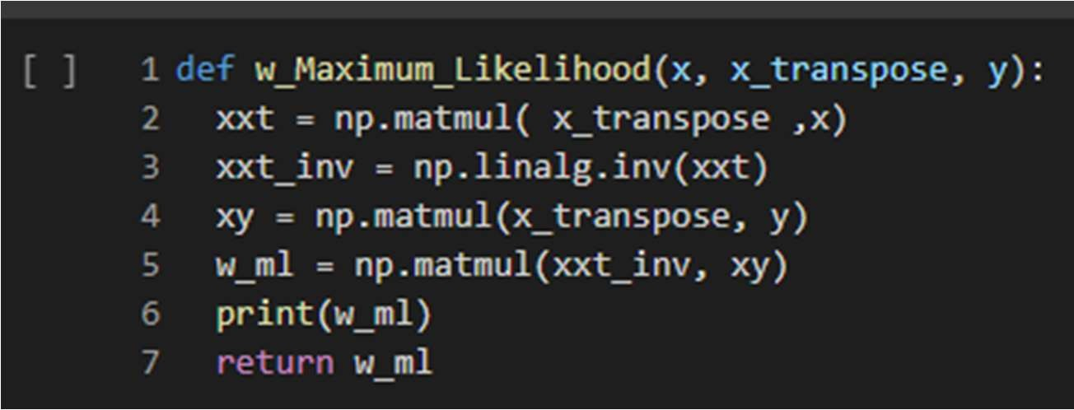

The formula for wML is as follows:

WML = (XTX)-1 XT Y

Here the shape of the wML is (100,1) which is same as the number of features.

1. **Code the gradient descent algorithm with suitable step size to solve the least squares algorithms and plot ||wt – wML||2 as a function of t. What do you observe?**

Following are the code snippet of the code for the Gradient Descent Algorithm.

Here As per observation, I took the alpha as

**alpha = 0.001**

**No of iterations = 600**

and the updation for the w is as per the following formulae: w = w - XTX

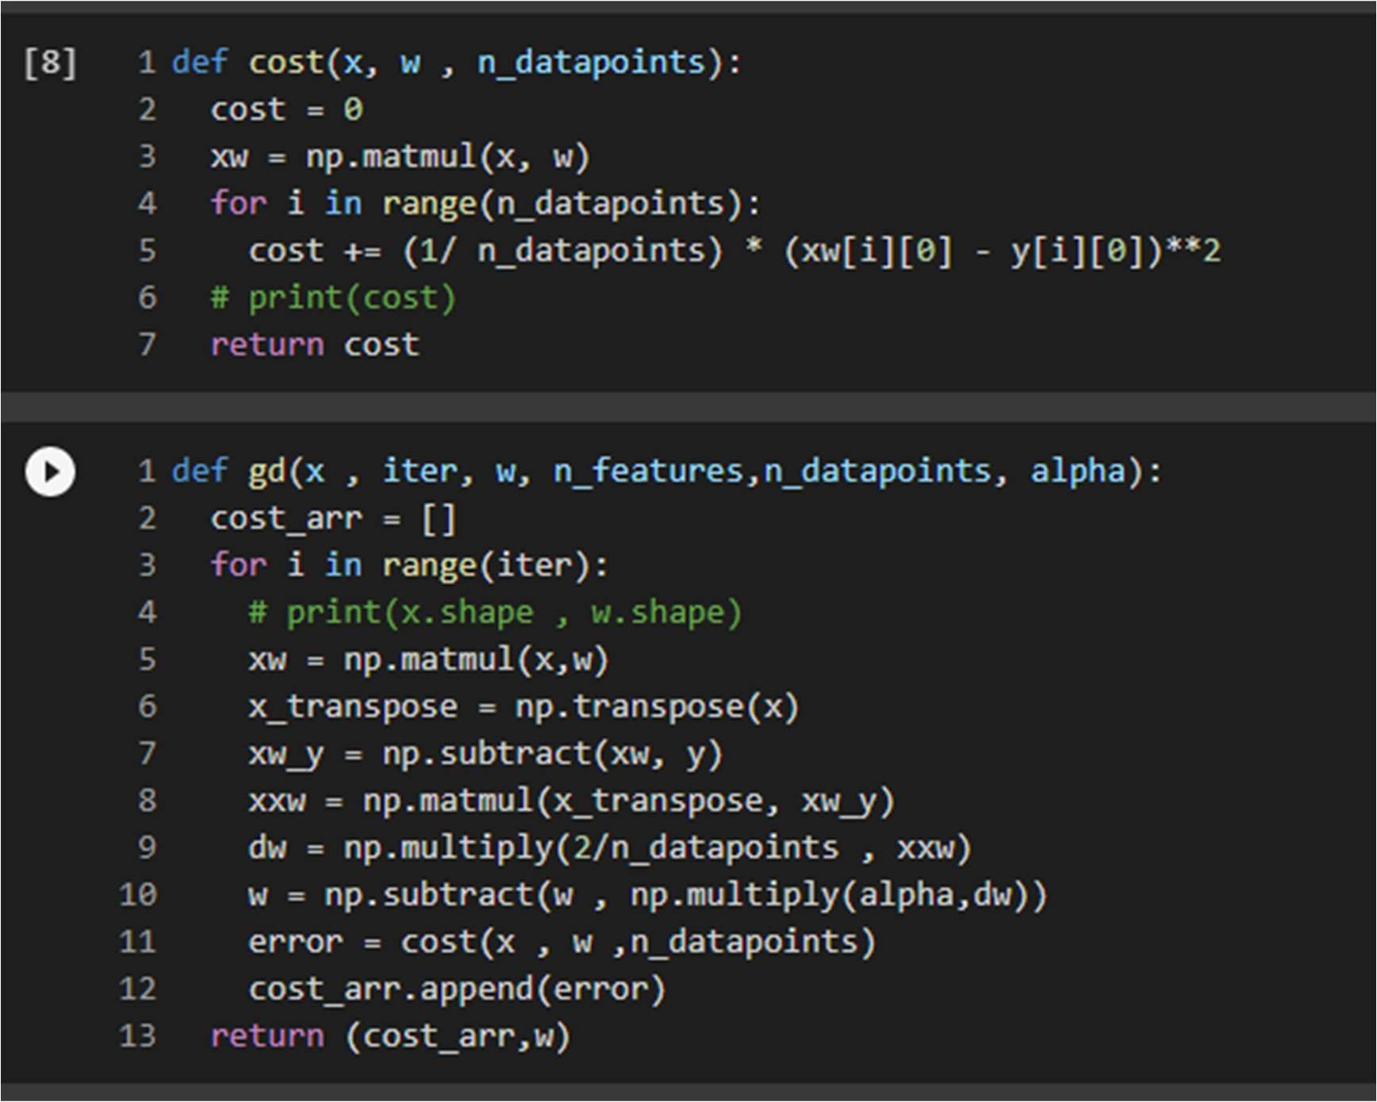

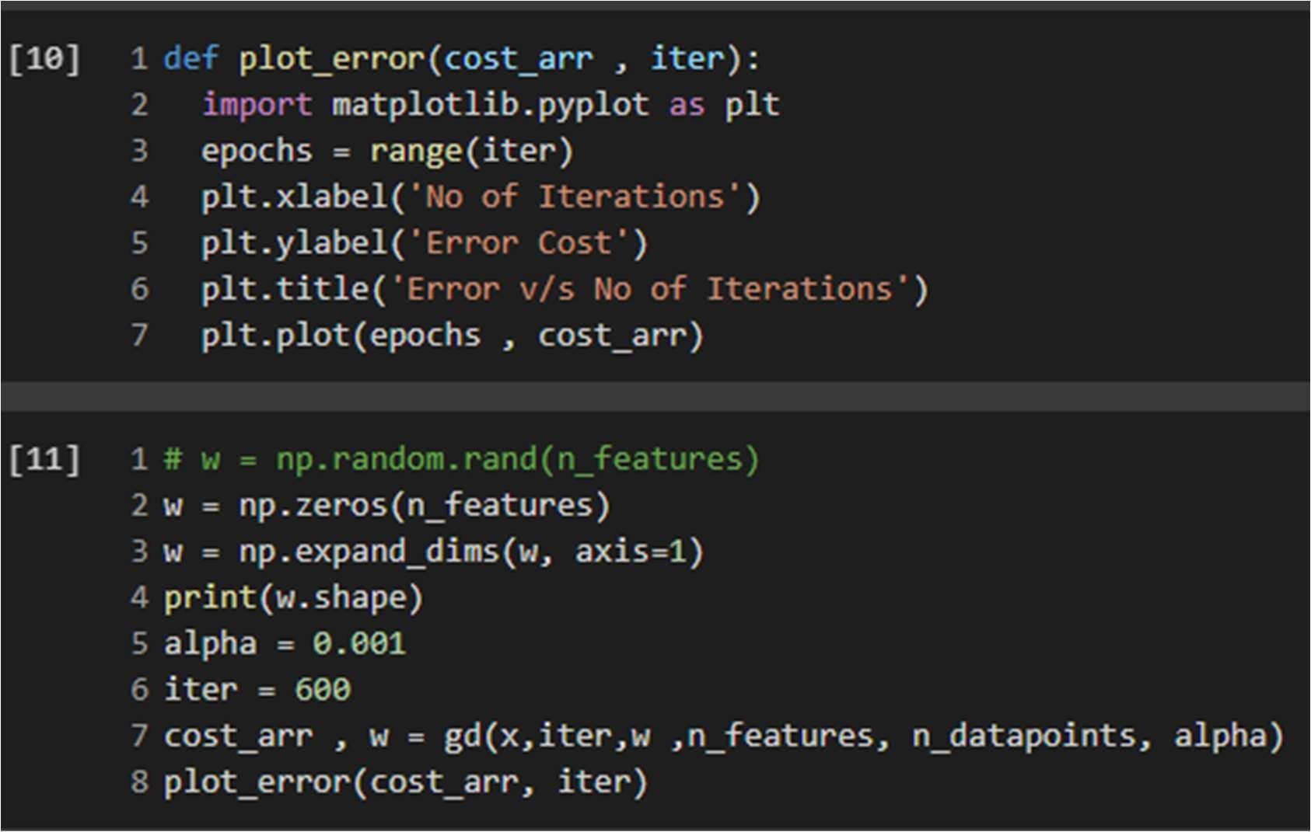

Here if we plot the error cost with respect to the number of iterations then the errors decreases exponentially in the starting as the number of iteration increases.

Uptil number of iteration = 50, the error drops from more than 4 to near to 0.

And after that the error decreases quite slowly as the number of iterations increases. The plot for the Error Cost v/s Number of Iterations is plotted as follows:

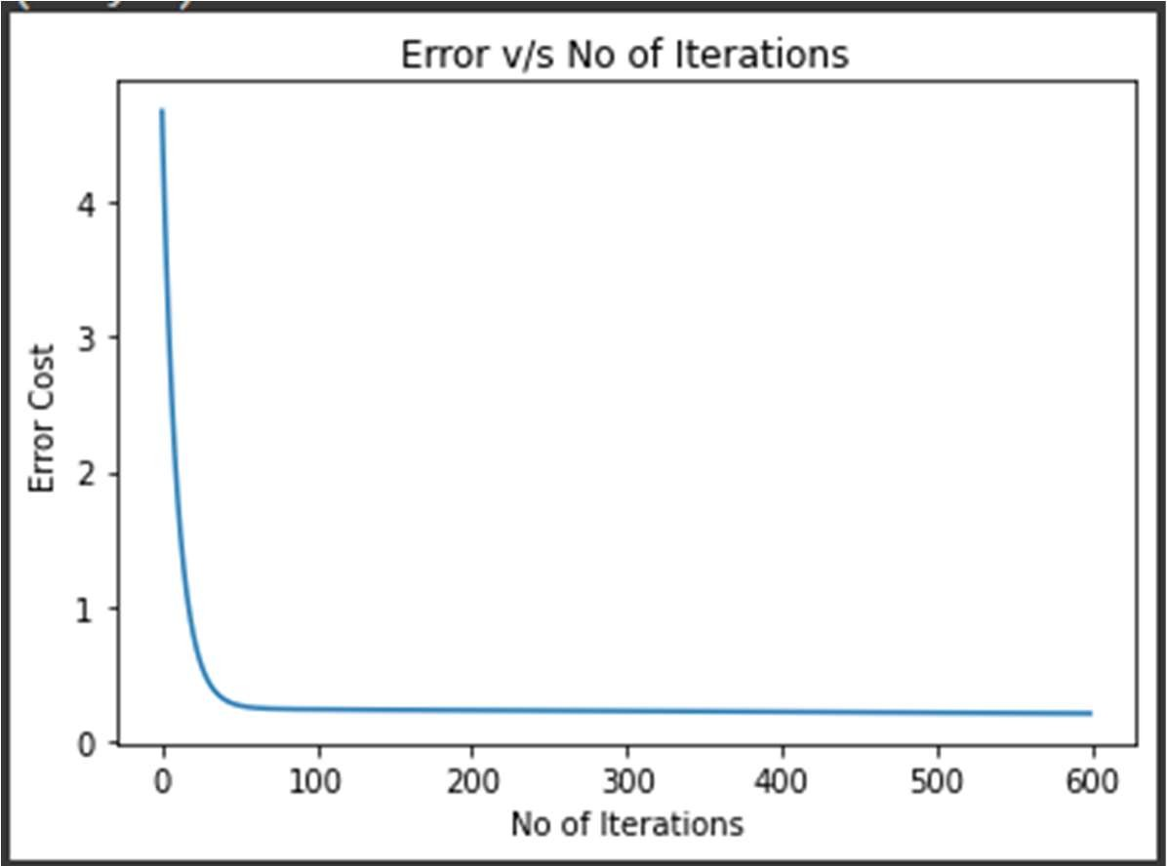

1. **Code the stochastic gradient descent algorithm using batch size of 100 and plot |wt – wML|2 as a function of t. What are your observations?**

The following are the code snippet for the stochastic gradient algorithm that I wrote :

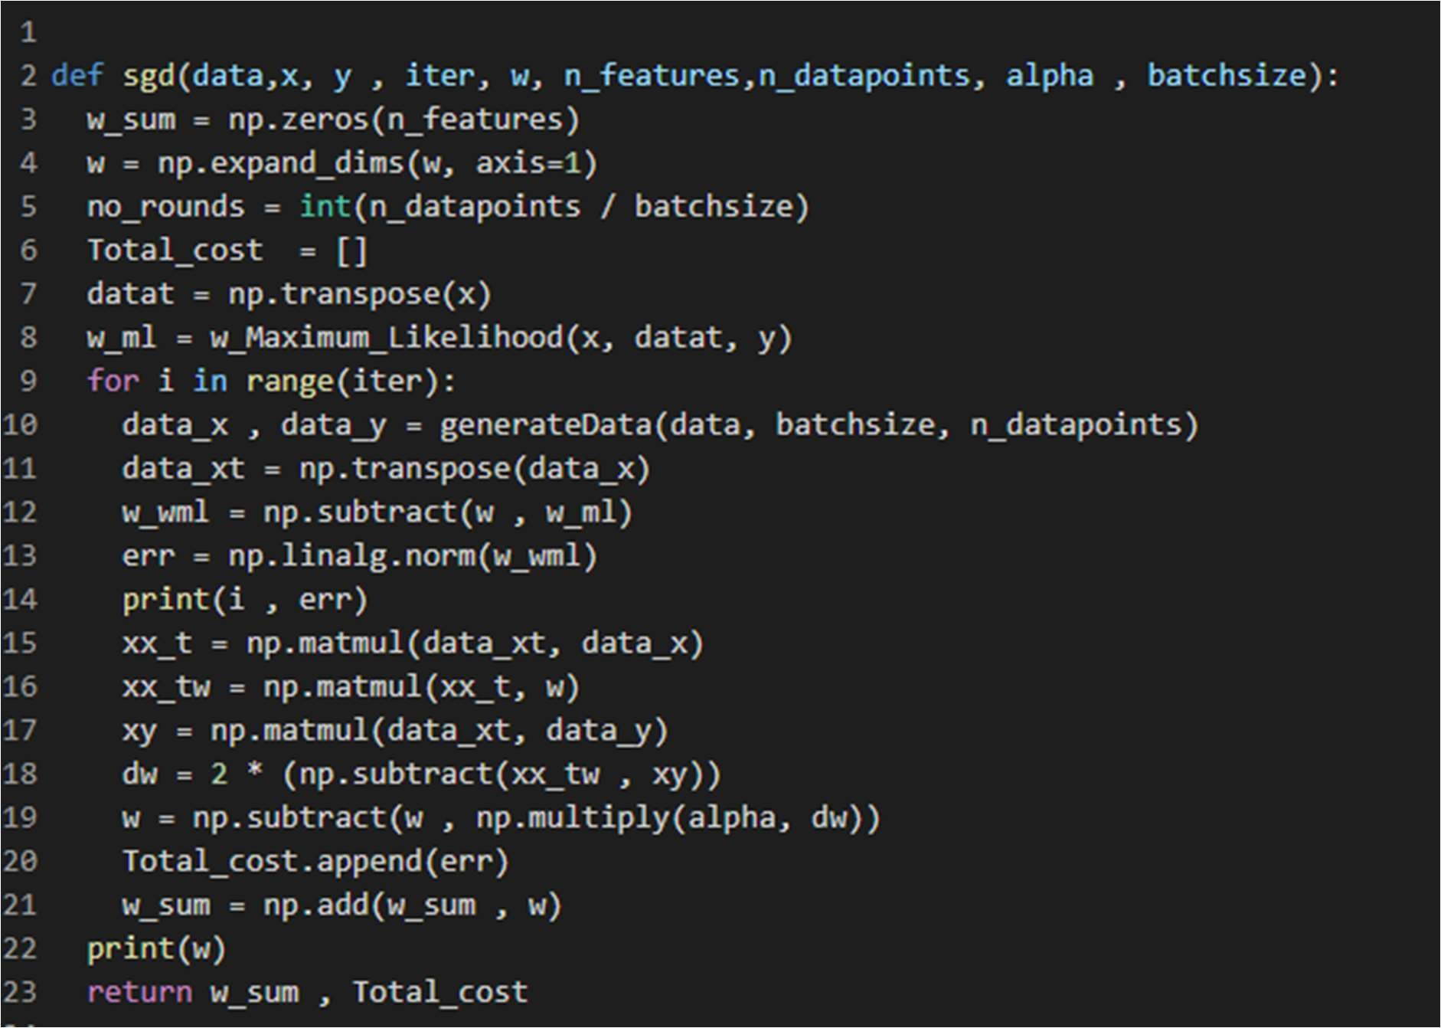

Here, we are taking the batch size of 100 for the datapoints.

Stochastic gradient descent computes the w with less number of computations without going over to the complete dataset.

Since it doesn’t go over the complete dataset and it considers only a certain batchsize(100 in our case) of dataset , so the error some time increases which calculating w for the number of iterations as the batch may not be the complete representation of the whole dataset.

But as we run it for the number of iterations, so the overall error decreases and we get the correct w.

For the batchsize of 100 , we get the following error vs Number of iteration graph:

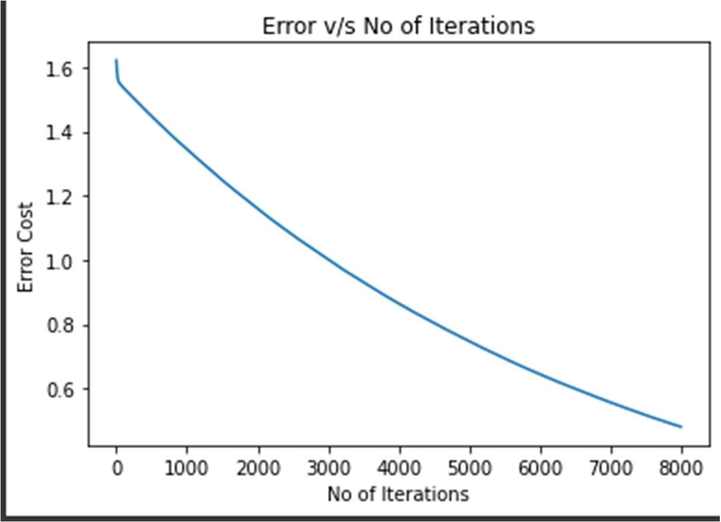

If we increase the batchsize to 1000, the plot is as follows:

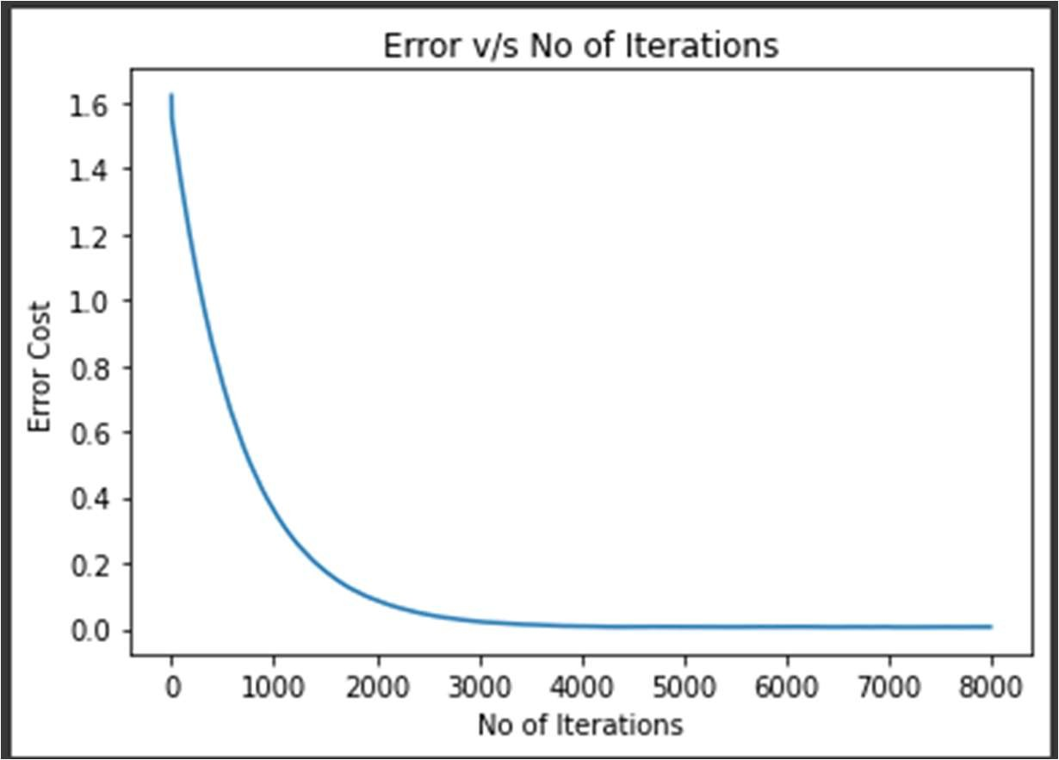

1. **Code the gradient descent algorithm for ridge regression. Cross-validate for var ious choices of λ and plot the error in the validation set as a function of λ. For the best λ chosen, obtain wR. Compare the test error (for the test data in the file A2Q2Data test.csv) of wR with wML. Which is better and why?**

Following is the code snippet for the Ridge Regression:

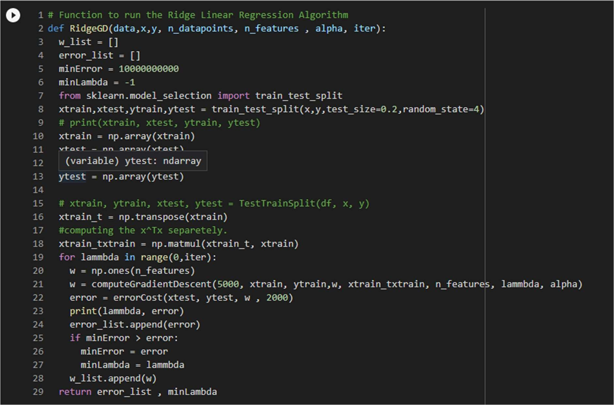

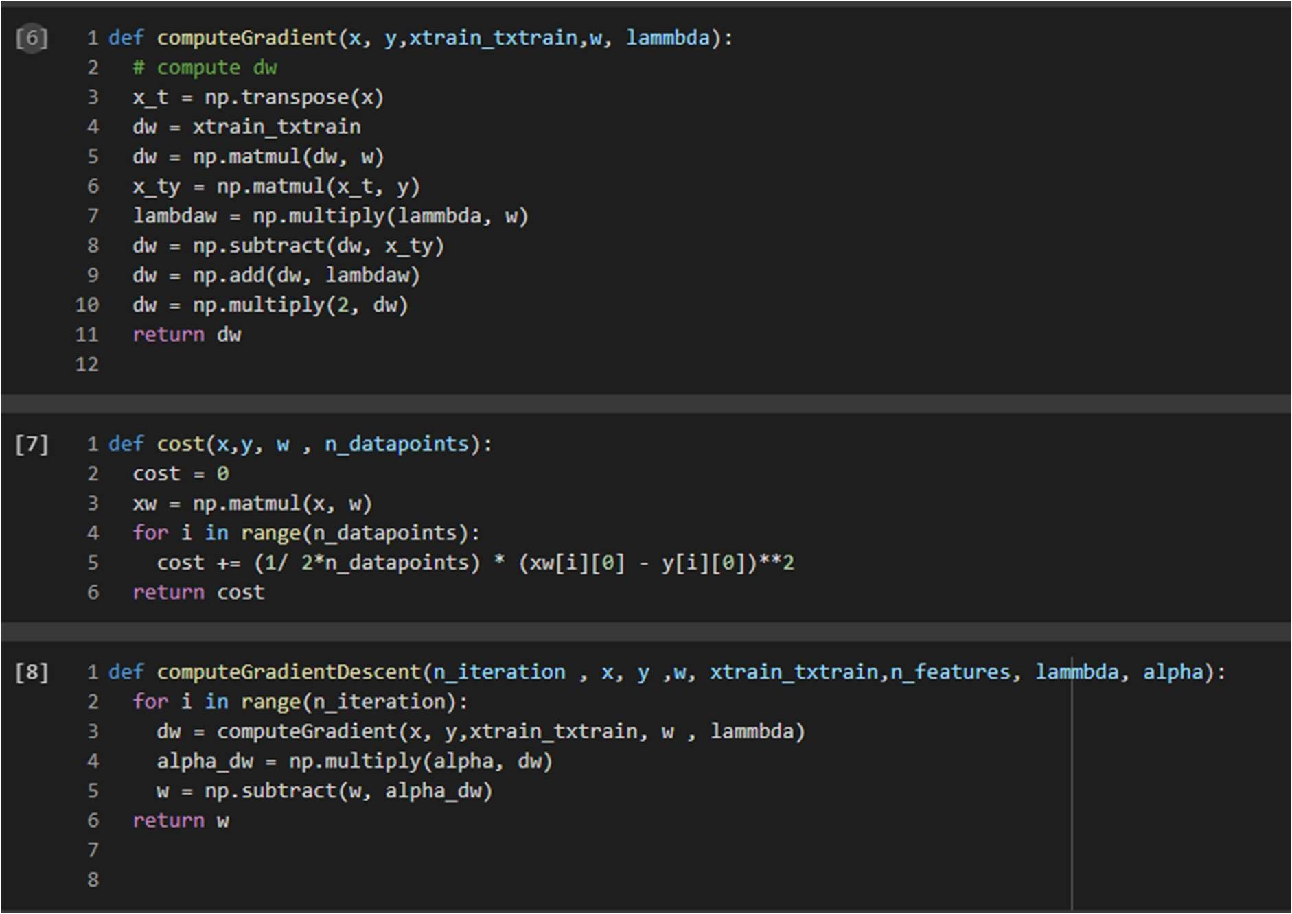

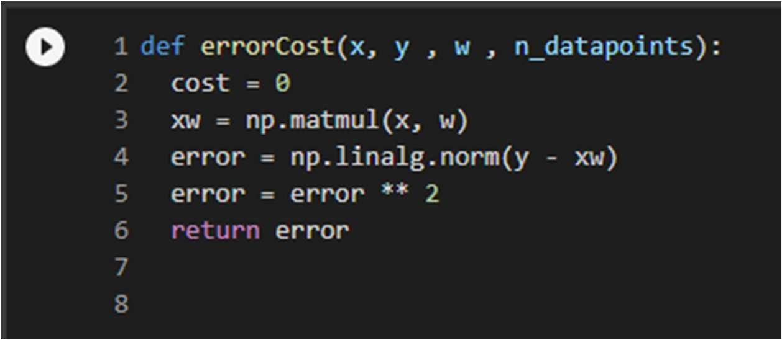

In the ridge regression, I split the complete data set in 80:20 ratio , and train for training data set to get the w.

After getting w and appropriate Lambda, I computed the error vs the value of Lambda graph and found out that the minimum error occurs for the value of lambda = 10.

After that I computed the wR for the testing dataset.

Comparing the WML and WR , I found out that the error in ridge comes out to be quite large

i.e. 8505.970671433826 (after optimizing a lot) as compared wML. which is

184.4323876725.

After plotting the plot of value of Lambda v/s the value of error, it comes out as:

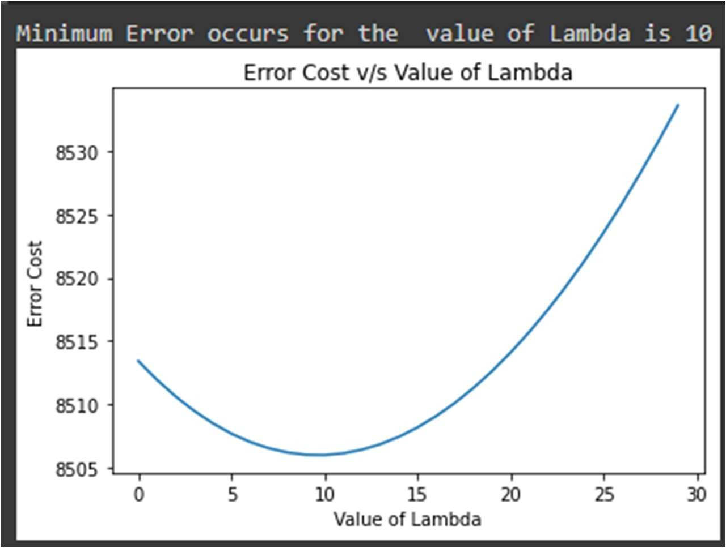

In the graph as we increase the value of lambda, the error decreases first as it computes the appropriate w. Firstly the w is the overfitted value for the training set, It reaches a minimum value and then again rises. Because as the value of lambda increases, value of error increases on training set but decreases on the testing set. But if we increase the lambda too high then the w began to come down towards x- axis and hence the error rises.